**7th Report**

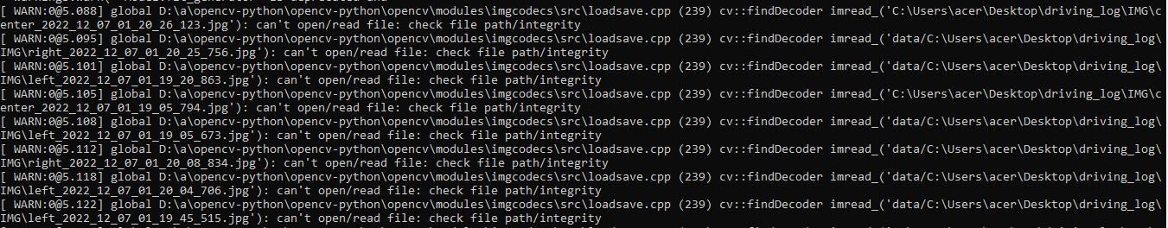 This session was the most complicated because I got stuck for a long time on the code of the last session, the code did not want to work, the Shell gave me that there was an error of path towards the images, but this was not true because the path was right.

So, I had to check line by line, but nothing to reproach. But after hours, I watched some videos on YouTube, which explained that the error can come from the model.fit_generator function, and so I had to add in the parameters that it takes the get_data function that was defined above.

After that, I started typing a new code that is based on the **model** code to be able to drive the car on Udacity, and see if it behaves well with the road, because this code will be similar to the one we will put in Invidia.

Here is the beginning of the code:

**DRIVE.PY :**

import argparse

import base64

from datetime import datetime

import os

import shutil

import numpy as np

import socketio

import eventlet

import eventlet.wsgi

from PIL import Image

from flask import Flask

from io import BytesIO

import tensorflow as tf

import h5py

sio = socketio.Server()

app = Flask(__name__)

model = None

prev_image_array = None

class SimplePIController:

    def __init__(self, Kp, Ki):

        self.Kp = Kp

        self.Ki = Ki

        self.set_point = 0.

        self.error = 0.

        self.integral = 0.

    def set_desired(self, desired):

        self.set_point = desired

    def update(self, measurement):

        # proportional error

        self.error = self.set_point - measurement

        # integral error

        self.integral += self.error

        return self.Kp * self.error + self.Ki * self.integral

controller = SimplePIController(0.1, 0.002)

set_speed = 10

controller.set_desired(set_speed)

@sio.on('telemetry')